**Experiment Title: 3.2**

Student Name: Rahul Maurya UID: 20BCS7260

Branch: CSE Section/Group: 20BCS716-B

Semester: 4th Date of Performance: 27-04-2022

Subject Name: CN LAB Subject Code: 20CSP-257

1. **Aim/Overview of the practical:**

Configure DHCP server using Packet Tracer.

1. **Task to be done:**

Understand how DHCP works.

1. **Apparatus/Simulator used (For applied/experimental sciences/materials-based labs):**

Cisco Packet Tracer

1. **H/W Requirement :-**
   * **Main Memory - 128 MB RAM**
   * **Hard Disk – minimum 20 GB IDE Hard Disk**
   * **44 MB Floppy Disk Drive**
   * **52X IDE CD-ROM Drive**
   * **PS/2 HCL Keyboard and Mouse**
2. Output:-

# Screen short of Network

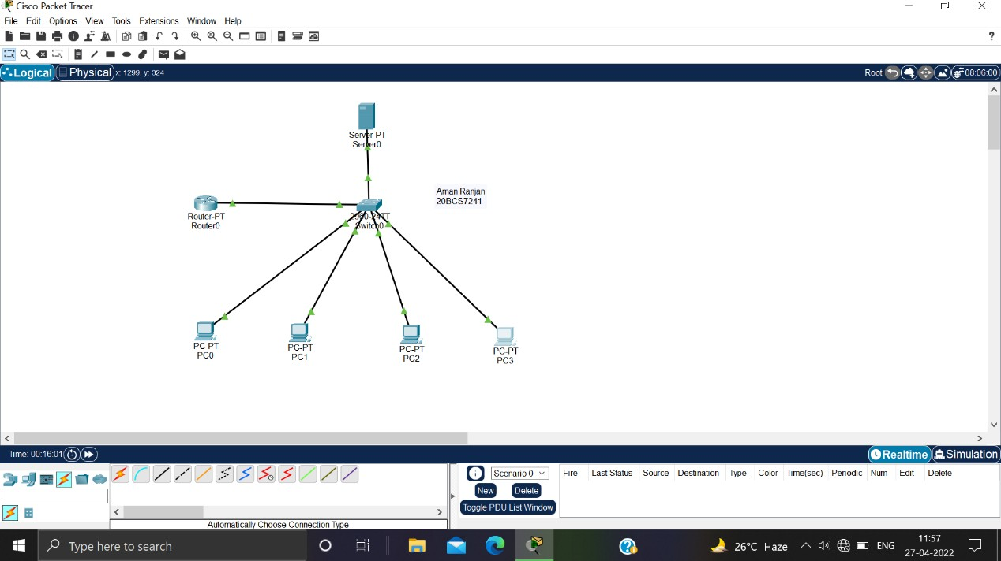

* + **Server Connection**

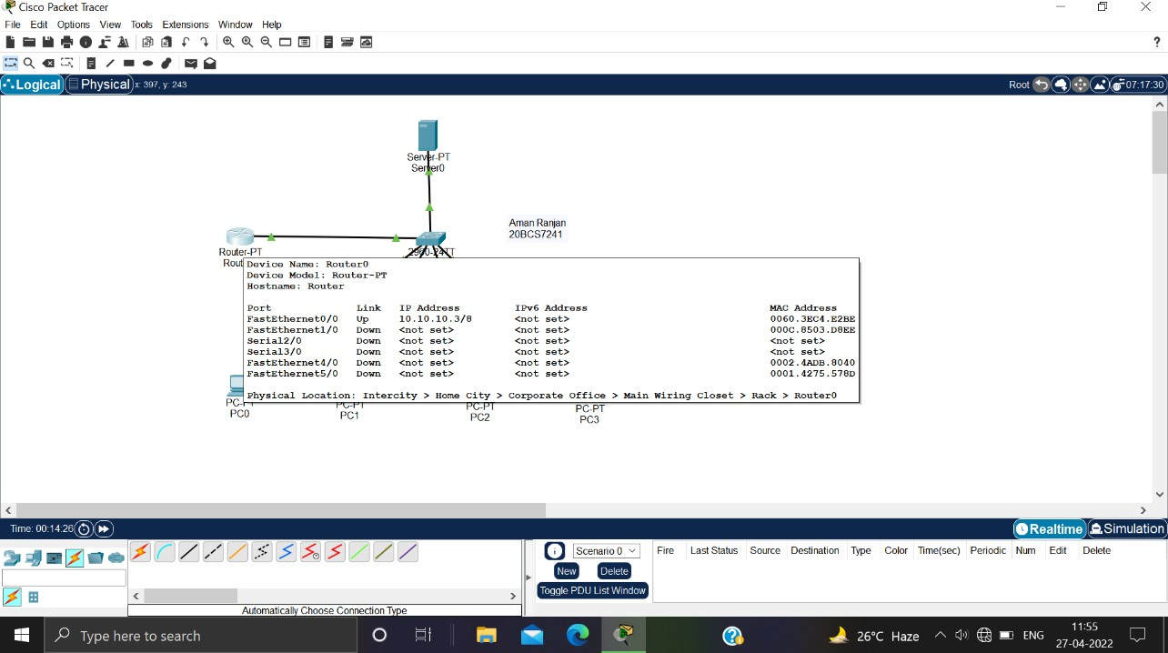

# Router Connection

* + **PC 0 Configuration**

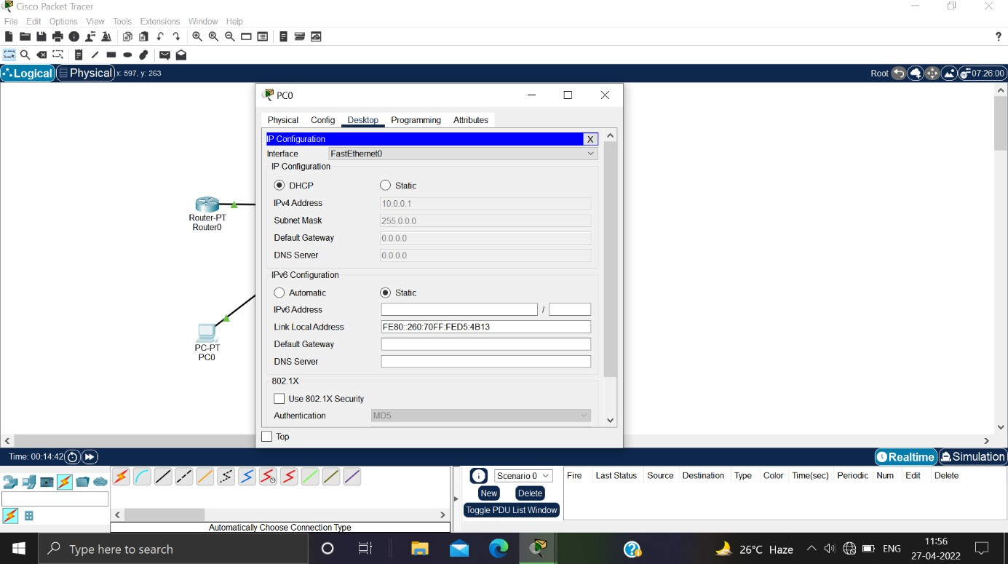

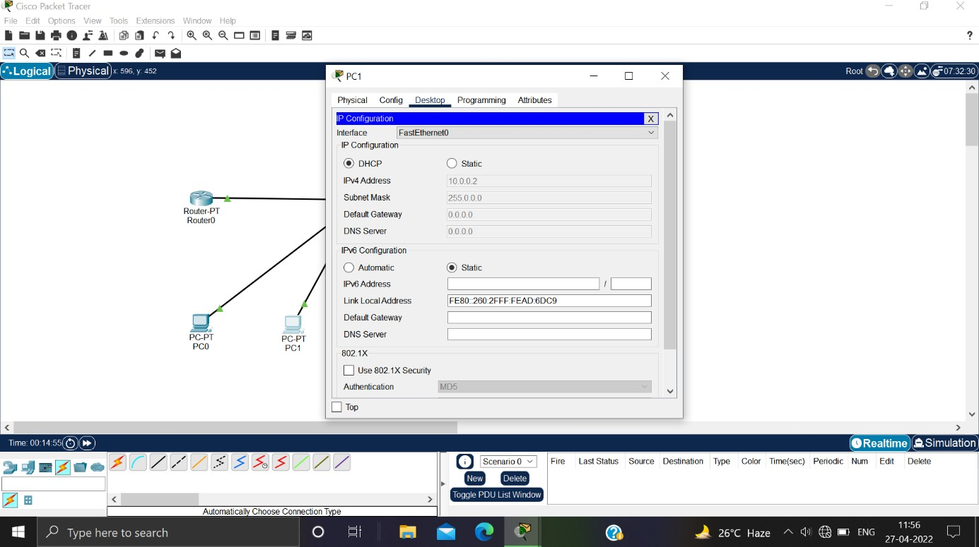

# PC 2 Configuration

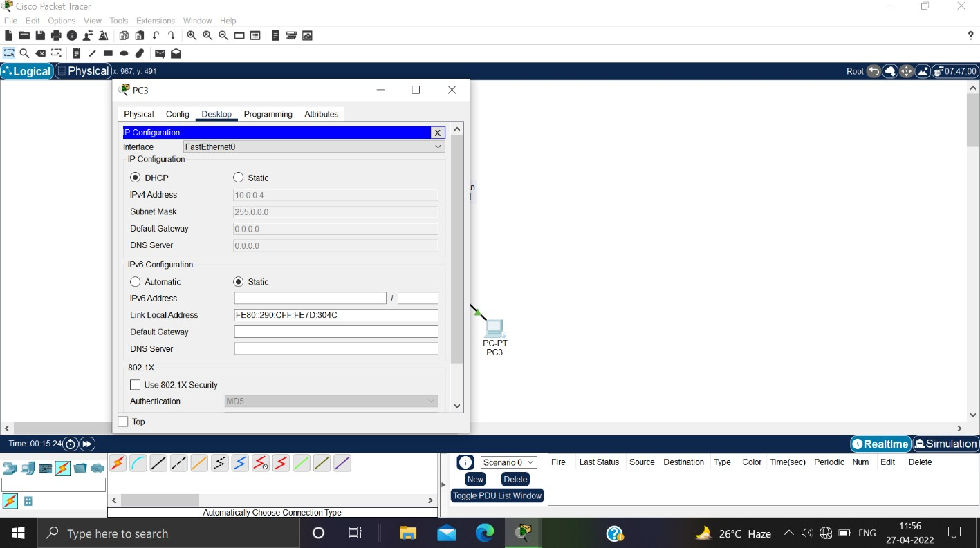

Learning outcomes (What I have learnt):

* + **DHCP server on one broadcast domain to serve hosts in a different broadcast domain.**
  + **understand concept of DHCP.**
  + **Build the network topology.**
  + **Configure DHCP server using Packet Tracer.**
  + **Understand how DHCP works**

Evaluation Grid (To be created as per the SOP and Assessment guidelines by the faculty):

|  |  |  |  |
| --- | --- | --- | --- |
| Sr. No. | Parameters | Marks Obtained | Maximum Marks |
| 1. |  |  |  |
| 2. |  |  |  |
| 3. |  |  |  |

|  |  |  |  |
| --- | --- | --- | --- |
| 4. |  |  |  |